Part 2
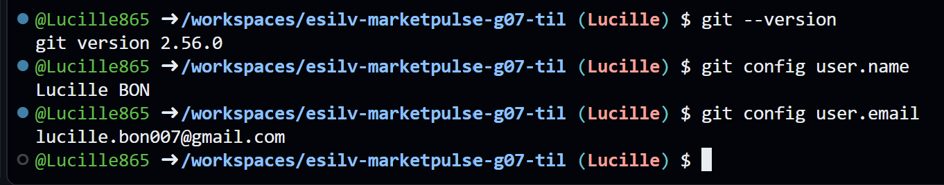
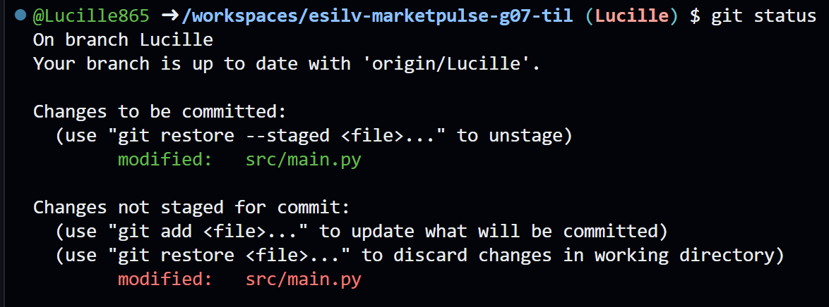
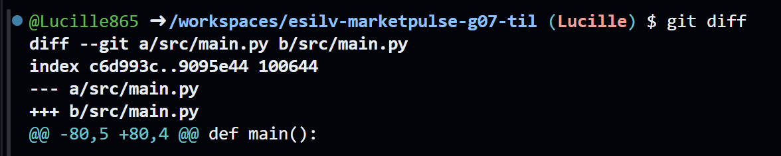

Part 4
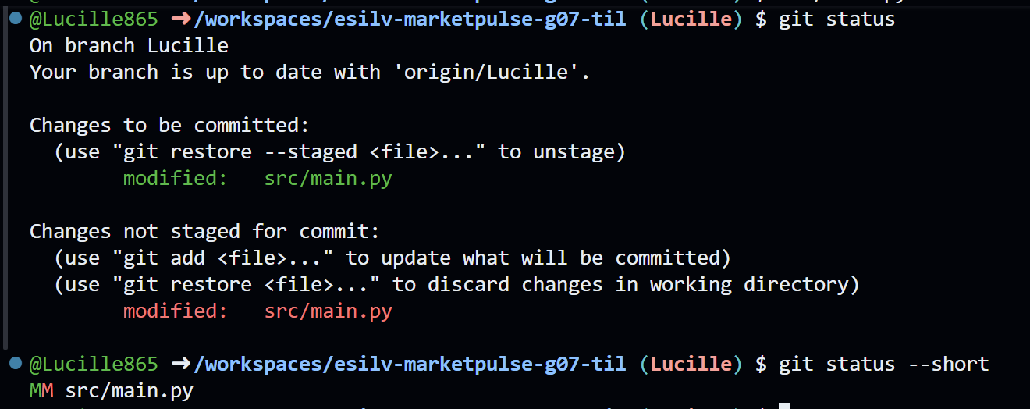

Part 5
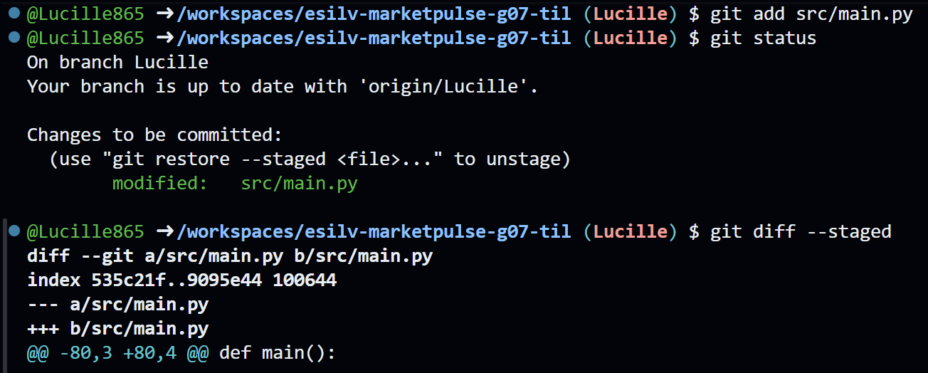

Part 6
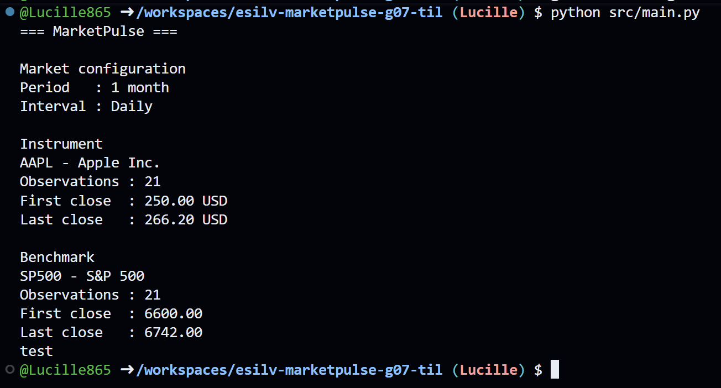

Part 7
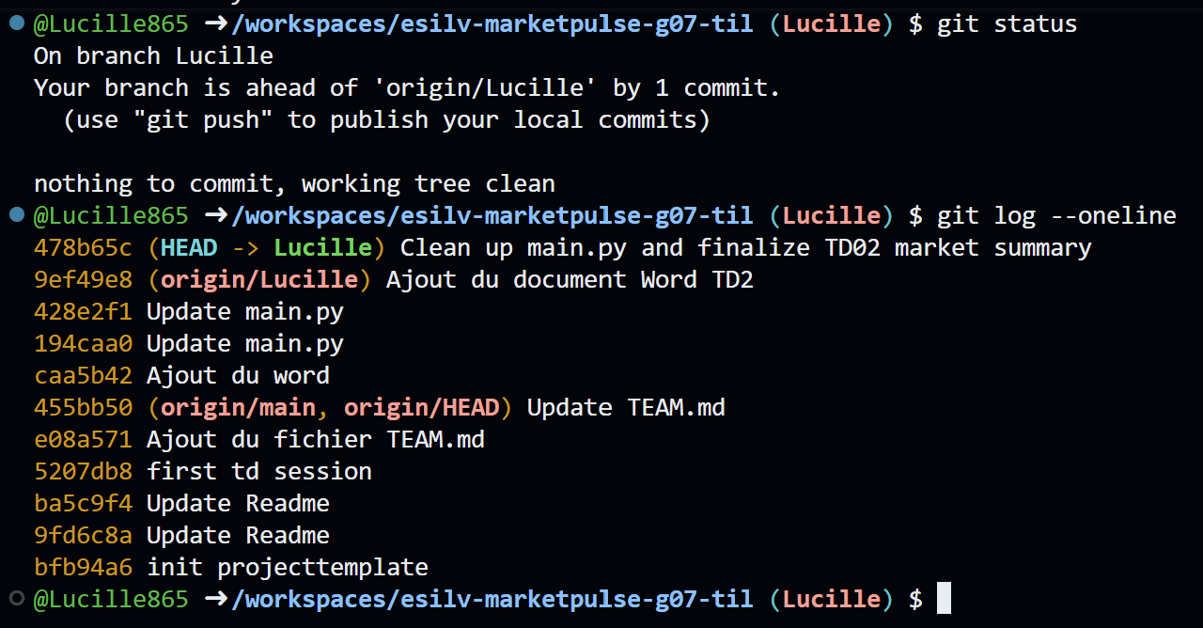
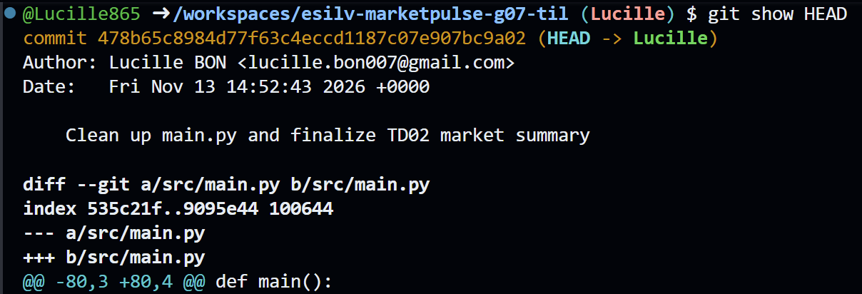
Part 10
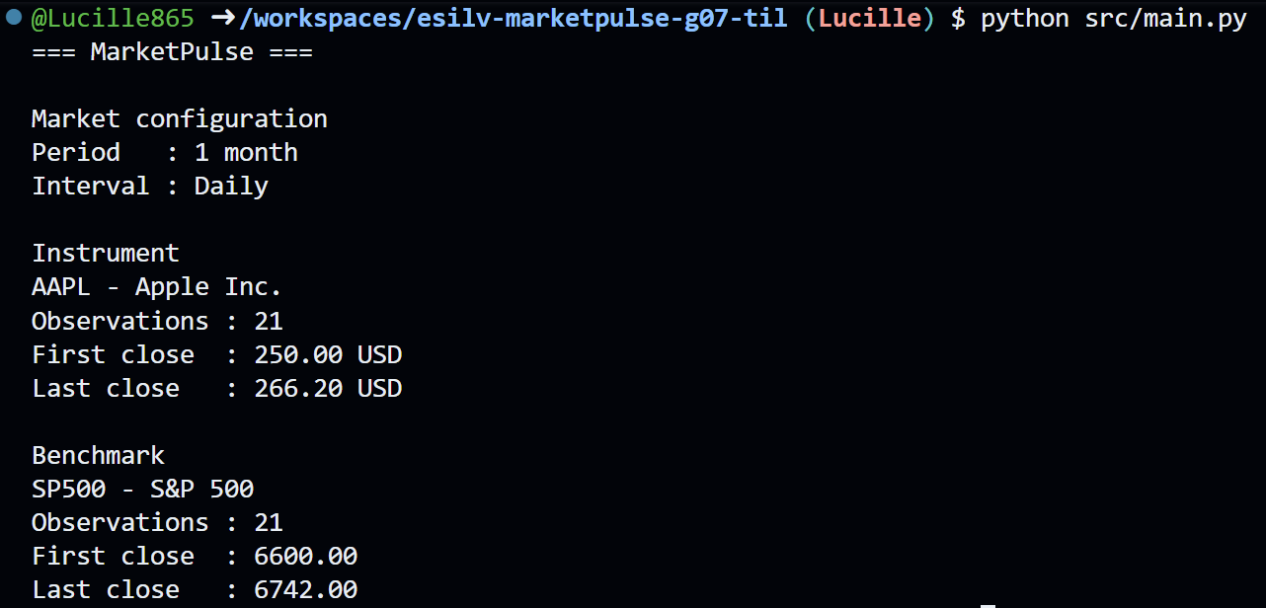
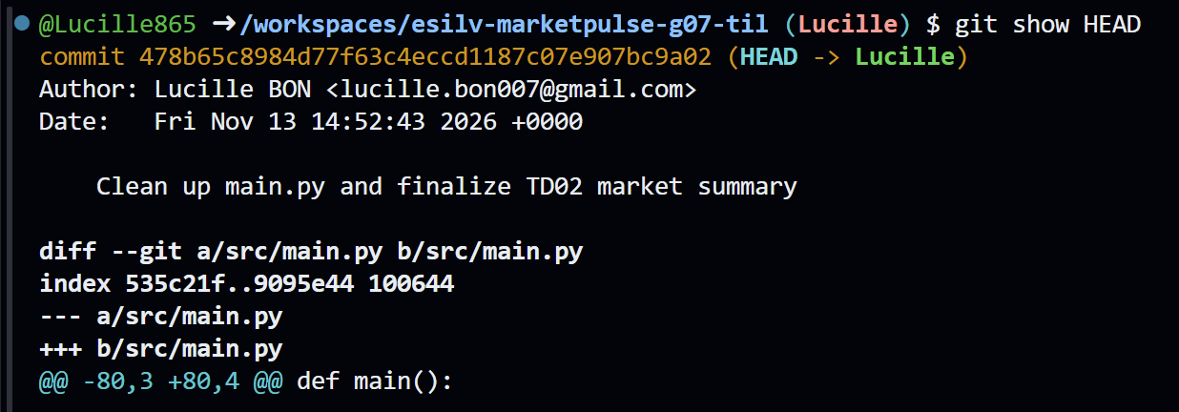

Optional 1 - Tracked vs untracked
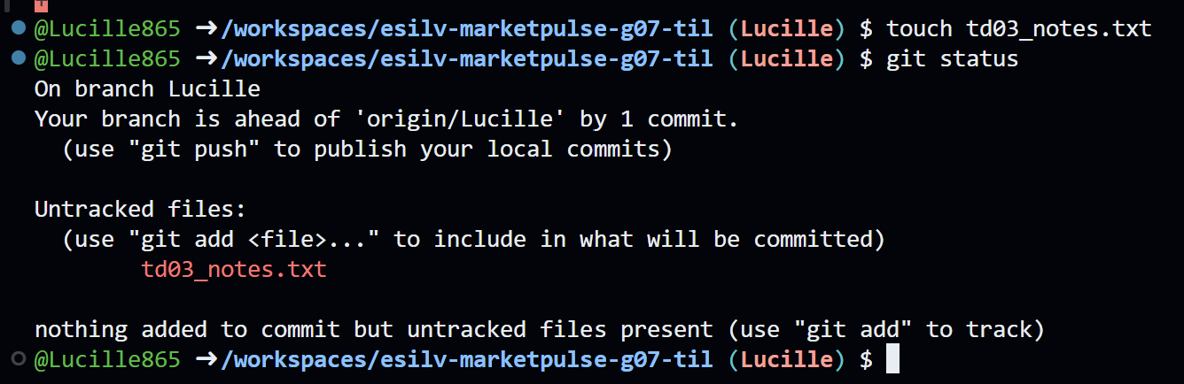
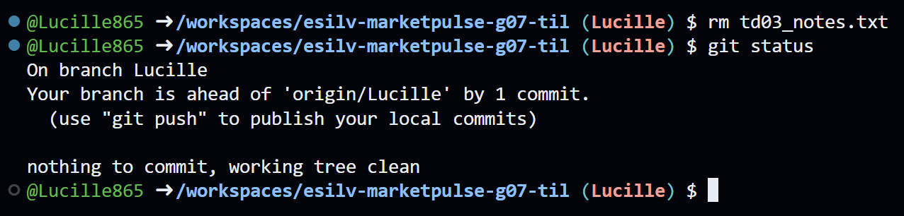

Optional 3 - Filter file history
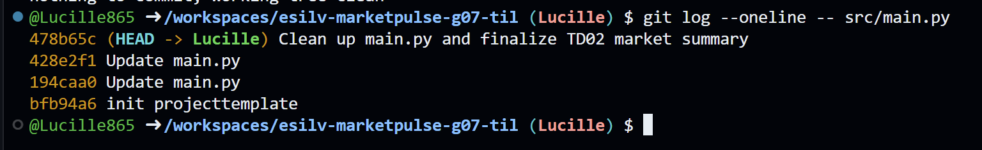
git log displays the commit history of the repository.
--oneline formats the output so each commit appears on a single line (showing only the short commit hash and the commit message).
-- src/main.py: Acts as a path filter (the -- separates command options from file paths) so Git ignores commits that did not touch src/main.py

Optional 4 - Graph view
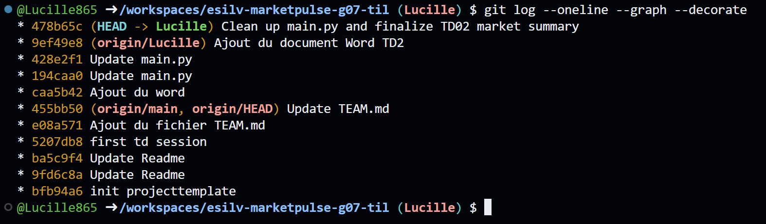

Optional 5 - Author filtering
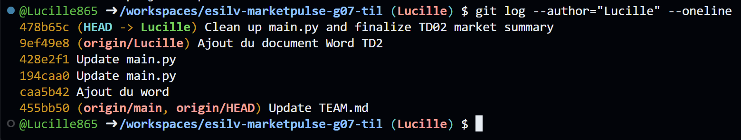

Optional 6 - Tracked files


